# Assignment 02

# Workstudy and Methods Engineering IE223



# Department of Mechanical Engineering

# Program: BS Industrial Engineering

# Name: Mohammad Abubakar Atiq

# ID: F2022031002

# Submit to: Sir Rehan

# Instructions:

## Write a comprehensive visit report of Honda car with Reference to Work study and Methods Engineering.

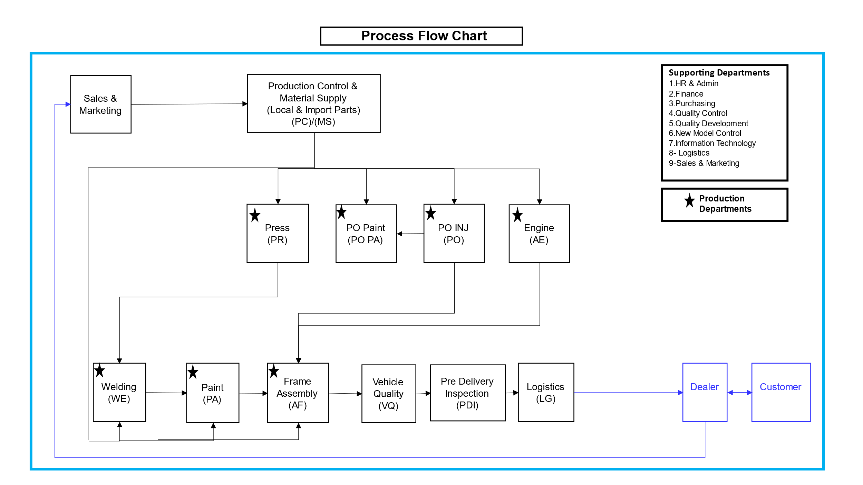

There is total 7 production departments which are interlink together, they are as follow:

1. Press (PR)
2. PO Paint (PA)
3. PO injection (PO)
4. Engine (AE)
5. Welding (WE)
6. Paint (PA)
7. Frame Assembly (AF)
8. Vehicle Quality (VQ)
9. Pre-Delivery Inspection (PDI)
10. Logistics (LG)

# Introduction

In this report, we will see the Honda car production facility and understand on the basis of work-study and methods engineering. We will further see the operations and methods usually occur in each department.

# Departments overview

# Press (PR)

In this department first shape of metal sheets occurs. After that they will be transformed into different body parts.

# Work-study:

Feeding metal sheets into presses, which are then stamped into specific shapes. We can understand and analyze cycle time, material handling, and die changing with times. In the sense of workstudy, we can optimize press speed and reducing downtime.

# Methods Engineering:

We can use Single minute exchange of dies and Just-in-time at inventory to increase efficiency.

# PO Paint (PA)

Pre – operation paint is used for coating the parts which maybe assemble in the line in order to prevent any corrosion.

# Work-study:

This involve the drying times and material handling.

# Methods engineering:

Finding and applying advanced molding techniques and monitoring systems.

# PO Injection (PO)

In this department, plastic parts are produced through injection molding.

# Work-study:

Study the cycle times, mold changing and finding defect rates. Finding the machine idle time and improving the injection process.

# Methods Engineering:

Finding new techniques for mold making.

# Engine (AE)

In this department, engine assembly and testing take place.

# Work-study:

Studying the line balancing, takt time and worker ergonomics for improving productivity and decreasing bottlenecks.

# Methods Engineering:

Observing the standard work procedures, error -proofing and engine assembly reliability.

# Welding (WE)

This department joins the different metal parts to form the car body structure.

# Work – study:

Finding and understanding the cycle time, joint quality and handling materials.

# Methods Engineering:

Finding and analyzing the robotic welding for precision, jig and fixture design for proper alignment.

# Other remaining departments:

# Paints (PA)

# Frame assembly (AF)

# Vehicle Quality (VQ)

# Pre – delivery inspection (PDI)

# Logistics (LG)

# Conclusion:

Visit to the Honda Car production facility give us the understanding of the operations occurs in different departments.